Writer: Sandip K Luis
The Baroda Figurative-Narrative Movement
The Baroda Figurative-Narrative Movement was a loosely organised but highly influential development in the Indian art of early-1980s against modernist abstraction in general and its puritanism in particular. Though this novel enthusiasm towards narration and figurative painting had not claimed any regional or ideological identity and the artists affiliated to it have been from many parts of India with varying styles of painting, its association with the Baroda artworld (whose nucleus was the Fine Arts Faculty of the M. S University in Baroda, Gujarat) made the appellative ‘Baroda’ in its name, along with its identification as a ‘movement’ or ‘school’, quite common. The inaugural event of the movement is considered to be the renowned ‘Place for People’ exhibition (1981) of which the participants were Jogen Chowdhury, Bhupen Khakhar, Nalini Malani, Sudhir Patwardhan, Gulammohammed Sheikh and Vivan Sundaram. The manifesto-like essay for the exhibition catalogue was written by the art historian Geeta Kapur. The complementarity of the movement with the general ‘return of painting’ in the international art scene of 1980s, the “figurative” and “narrative” turn in the rejuvenating British painting and last but not the least, many of its artists’ institutional alliance with the Royal College of Art and the British artworld made it a highly successful venture whose most important and immediate result in the increasingly liberalising India was the creation of a visible art market.
FORMATION OF THE NAME AND IDEOLOGY
In discussing the Baroda-centred art practices of 1980s, the term ‘figurative-narrative’ carries an ambiguous lineage. Though it first appeared in Geeta Kapur’s essay ‘Realism and Modernism’ (1979-80), the term as such was not present in the catalogue essay written for the ‘Place for People’. Instead, in Kapur’s as well as many other writings produced by the proponents of the movement, the concepts ‘figurative’ and ‘narrative’ enjoyed separate but synergetic functions – the former to brand the new artists against the abstractionists and the latter, vaguely, to the linguistic outcome of their aesthetic.
Whereas the term ‘figurative’ was already established in Indian art as an oppositional category against ‘abstract’ by the end of 1960s, the term “narrative” was, according to Sheikh, first introduced by the British artist Timothy Hyman (who served as a Visiting Professor in Baroda between 1980 and 1982). In 1979, Hyman curated a travelling exhibition, ‘Narrative Painting: Figurative Art of Two Generations’, in Britain, to which he invited Bhupen Khahar as an honorary member, along with a group of British artists including R. B. Kitaj, Peter de Francia (both from the Royal College of Art and the mentors of Sundaram and Kapur respectively) and Howard Hodgkin (who was, despite being an abstract painter, a close associate of the artists of ‘Place for People’ as Sundaram’s painting People Come and Go, displayed in the exhibition, suggests.
Whereas the enthusiasm towards figurative painting in the British art of early-1980s was received highly critically by its leftist circles, the figurative-narrative movement in the Indian counterpart of the same period maintained almost a leftist, if not exactly Marxist, identity with less controversy, at least until the intervention of the ‘Indian Radical Painters and Sculptors Association’ (see below). Part of its reason lies in the successful launching of the Journal of Arts and Ideas in 1982 (until 1999), a leftist trimonthly, which had Kapur, Sundaram and Patwardhan as the founding members in its editorial board. (The first edition of the journal carried an extensive review of ‘Place for People’ by Ajay Sinha and an art historical justification to figurative-narrative art by Kapur.) Moreover, though Kapur’s catalogue-essay for ‘Place for People’ was devoid of any ideological partisanship other than a strong defence of figurative art, her ‘Realism and Modernism’ essay was originally a paper presented at a seminar on ‘Marxism and Aesthetics’ – organised by the Kasauli Art Centre (founded by Sundaram) with the collaboration of the Indian leftist journal Social Scientist in 1979. Kapur’s theorisation of “figurative-narrative” as a synonym for realism in art, that too with extensive references to the recently released English translation of the famous ‘Realism-Modernism debate’ of western Marxism, placed the new aesthetic in a discourse diametrically opposite to Hyman’s subjectivism. Thus, drawing from Frederic Jameson’s afterword to the debate, she argued that “the dialectical thrust of realism/modernism seems to point towards a figural art that is narrative and objective”. The representative of such a “realist” aesthetic for Kapur was the recent art of R. B. Kitaj (who himself was, as she notes, an admirer of Walter Benjamin as well as the literary realists like Tolstoy and Dostoevsky) in which “ordinary people” were portrayed in “the way they expose the viewer to other’s pain, to his own bad conscience, to a shared neurosis” .
However, it is important to note that the movement, in its entirety, did not have a coherent ideology or outlook other than a liberal-pluralist one verging on leftist theorisations. As Sundaram put it later, “because it [‘Place for People’] was not organised as a movement to support a manifesto, each of us have retracted a little bit into our own personal preoccupation and let the work follow a logic of its own.” Only a survey of the sociocultural context of the time can tell us how the movement could be, despite its short lifespan and lack of any explicit ideology, an important event in Indian art history.
CONTEXT
A motivating force behind the rediscovery of realism in the aesthetic of the figurative-narrative was the historical necessity to respond to the overarching institutional crisis of modernism in India. Unlike in the advanced capitalist countries such as Britain where the return of painting and disavowal of avant-gardist strategies were received as conservative trends, an anti-institutional or avant-gardist intervention in art was generally discouraged even in the leftist pockets of the Indian artworld. The decline of India’s state’s modernization project and the rise of non-secular forces in early-1970s, the declaration of Emergency in 1975 over two years and following it, the chaos in the national politics were paralleled in the Indian artworld by similar instances of decay and degeneration. The abstraction in art reached an extremely esoteric and occult status in the so-called “Neo-Tantric” movement in early-1970s. The Emergency was publicly supported by the most celebrated artist of Indian modernism, M. F Husain, through a series of paintings. Also, the state institutions of art such as the National Gallery of Modern Art and the Lalit Kala Academy faced much criticism for their controversial aesthetic preferences as well as nepotistic policies (for example, see Kapur’s ‘Art Criticism in India’ published in 1972 and the catalogue of ‘Six Who Declined to Show in Triennale’, a protest exhibition in 1978 in which many of the artists of the later figurative-narrative movement actively took part). It was in such a context which can be identified as a ‘decline of modernism’ that a search for an alternative arrived at the idea of ‘figurative-narrative’.
It is not at all accidental that this new interest in realism following modernism’s decline perfectly coincided with the rise of a ‘new Indian middle class’. Barring the works of Patwardhan (for its working-class realist content), most of the paintings exhibited in the ‘Place for People’ can be clearly seen as autobiographical narratives of the middle class artist himself; quoting Chowdhury, “the little but intimate corners of my own” . Thus, Sheikh’s About Waiting and Wandering (1981) depicted, and was painted for his wife Nilima Sheikh who was also an artist. His Revolving Routes (1981) shows a self-portrait of the artist at centre, as indulged in his personal reveries about from childhood to present life with friends and colleagues of the Baroda artworld, including Kapur, Sundaram, Khakhar and Hyman. Sundaram exhibited Portrait of his Father (1980), K. V. K Sundaram, a powerful bureaucrat and Padma Vibhushan holder, and People Come and Go, a representation of Khakhar’s private studio and his friends including Hodgkin. Malani’s Concerning a Friend (1981) depicts a close conversation between the artist and Geeta Kapur, located in Kapur’s fashionable apartment. And Khakhar’s You Can’t Please All (1981), a complex painting prefiguring his later declaration of gay identity, sarcastically narrated the futility of public life and the lure of private pleasures. Thus, it is such personalised representations of middle class subjectivity and fantasies that at once became, as the title ‘Place for People’ suggests, an ‘objective’ and ‘realistic’ representation of the Indian ‘people’ of early-1980s.
CRITICISM
The crux of any criticism against the movement lies in the varying responses to the question of how was it to deal with the crisis of the 1970s and the concurrent decline of modernism. Was it avant-garde or realism that was the effective antidote to such a degenerated modernism? In fact, many of the avant-gardist or surrealist strategies (for example, fragmentation through allegory, multiple perspectives etc.) can be found in the figurative-narrative language, while strikingly missing the avant-garde’s critique of the institution of art. Thus, Kapur’s later thesis that “we had a modernism without avant-garde” only describes the “reformist” nature of Indian modernism in which figurative-narrative movement has very much been a part of.
It is a point of debate whether the aesthetic of the figurative-narrative artists was quite realist as Kapur had envisaged or simply postmodernist as it was later severely criticised in the quasi-avant-gardist manifesto of the ‘Indian Radical Painters and Sculptures Association’ written by one of its members, Anita Dube in 1987. For Dube, “The Narrative movement, in India, […] taking character, from the British example and continuing a tradition of colonial patronage and approval; [was] the Indian version of an archaeology of historicism emerging from the post-modern”. Whereas Dube and her colleagues were right in pointing out the role of the British artworld in the success of the figurative-narrative movement (though it is not clear whether the latter’s relationship to the former was a subservient one or not), their branding of the new aesthetic as “postmodern” following Frederic Jameson’s essay, ‘Postmodernism, or the Cultural Logic of Late Capitalism’ (1984), could not go further due to their inability to locate the crux of the existing historical problematic. This latter point is clearer in the following remark made by Dube: “With the use of multiple references […], pseudo historical content, […] narration, [and] a rhetorical tone, a myth is created [in the figurative-narrative paintings] which says that, that which is being portrayed is reality and the ‘historical’”. This criticism misses its target in the fact that it was not exactly in the alleged postmodern language of the narrative painters that history is confused with myth, but rather the proto-fascist Hindutva ideology and its populist nationalism to which these artists fought from the inception of the movement itself . Whereas Sheikh’s City for Sale (1981) was an allegorical narrative of the artist’s silent presence within and against the violent world of religious fundamentalism, Khakhar’s Celebration of Guru Jayanti (1980) – exhibited in ‘Place for People’ along with Sheikh’s painting – sarcastically represented a religious moment in its utmost profanity. Dube and her colleagues failed to notice that the figurative-narrative artists’ use of multiple references, fictive and actual, under the claim of being historical was intended to oppose the similar efforts made by the proto-fascist forces of the time to synthesis the cultural multiplicity of the nation to a repressive homogeneity. But at the same time, they were quite right in locating certain “logic of multinational capitalism” in the movement’s institutional success, if not in its aesthetic straightforwardly. The exhibition ‘Timeless Art’ in 1988, which was solely dedicated to the new figurative art by including all six painters of ‘Place for People’ along with the several upcoming artists of the Baroda artworld, caused controversy with Sotheby’s auction of the exhibits (the first time for Indian art) and the protest of the Indian Radical Painters and Sculptors Association against it. Whereas the protest was the last collective action of the Association outside Kerala (the native place of its members except Dube), the success of the exhibition and auction consolidated the presence of the personalities associated with the figurative-narrative movement for the coming decades of Indian art.
References and Further Reading:
Dube, Anita. (1987) "Questions and Dialogue ." Manifesto of Indian Radical Painters and Sculptors Association. Exhibition catalogue.
Gopinath and Fibicher. (2007) “In Conversation with Gulammohammed Sheikh," Horn Please: Narratives in Contemporary Indian Art, Hatje Cantz.
Hyman, T. (1979) Narrative Paintings: Figurative Art of Two Generations, Bristol: Arnolfini.
Kapur, Geeta. (1979-80) “Realism and Modernism: A Polemic for Present-Day Art.” Social Scientist, no 5-6, Vol. 8, Dec. 1979-Jan. 1980, pp: 91-100
Kapur, Geeta. (1981) "Partisan Views about the Human Figure," Place for People, Bombay: Jahangir Art Gallery ; Delhi: Rabindra Bhavan.
Rajadhyaksha, Ashish. (1997) "The Last Decade" In Contemporary Art in Baroda, edited by Gulammohammed Sheikh. Tulika: 213-344.
Sinha, Ajay. (1982) "Place for People-New Images", Journal of Arts and Ideas, October-December 1982: 19-28.
Sinha, Ajay. (1997) "Envisioning the Seventies and the Eighties ", Contemporary Art in Baroda, edited by Gulammohammed Sheikh. Tulika: 146-209.
Sundaram, Vivan. (1984) “Language, Narrative and the Viewer: A Personal Reading of the Contemporary Indian Narrative Art”, Nandan, Shantiniketan: Viswabharati: 57-64.
Sundaram, Vivan. (1991) “A Tradition of the Modern”, Journal of Arts and Ideas, No 20-21, March 1991: 33-40.
Illustrations
- 'People Come and Go' (1981) Vivan Sundaram, Oil on Canvas, 152.4cm x 123.2cm, Courtsey-Asia Art Archive (http://www.aaa.org.hk/Collection/CollectionOnline/SpecialCollectionItem/3456)
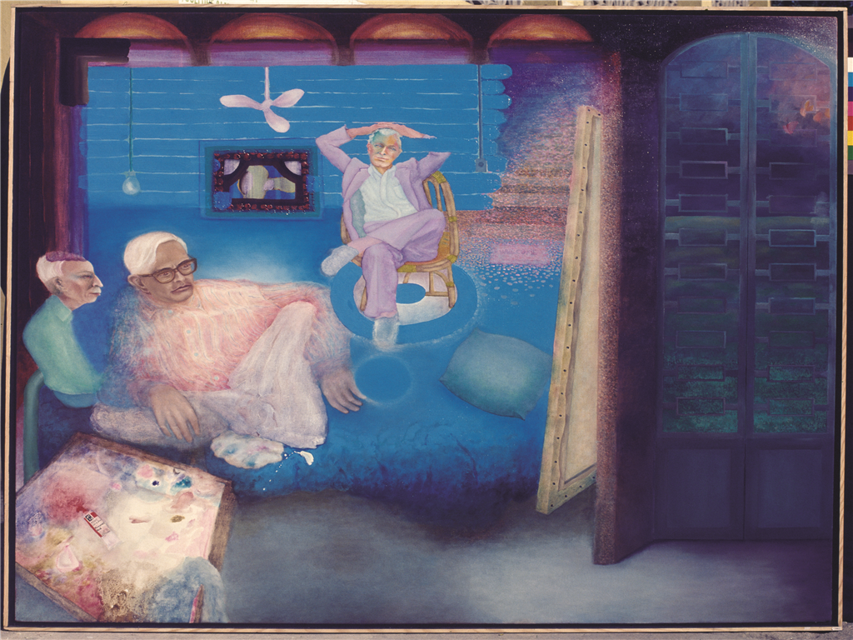
- 'City for Sale' (1981-4) Gulammohammed Sheikh, Oil on Canvas, Trustees of the Victoria and Albert Museum, Image Courtsey-www.theotherspaces.com (http://www.theotherspaces.com/Gulam-Sheikh/1445/gallery.aspx)
